
OPAS G2
Management Referral – Manager Process Only
January 2022
Contents
Introduction 3
Using the G2 System 4
Management Referrals 5
Creating a Referral 6
Consent 10
Pre-Consent 10
Status Updates as OH Progress the Referral 12
Receiving A Response from the OH Team 15
Interim Updates 17
Document Control 18
Copyright Notice: 18

Introduction
This guide is to details how a user of the OPAS G2 uses Management Referral Configuration in G2.
The guide will explain the following information:
- Using the G2 System
- Creating a Referral
- Consent

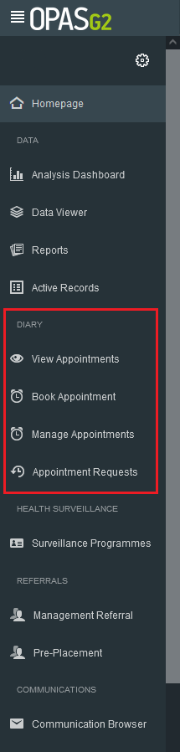
Using the G2 System
Use the Menu on the left-hand side as the main navigation through the system.

This user guide focuses on Management Referral from the Manager point of view.

Management Referrals
Log in as a Manager
Upon logging in, the Homepage will chart the Active Management Referrals you have open and their corresponding status
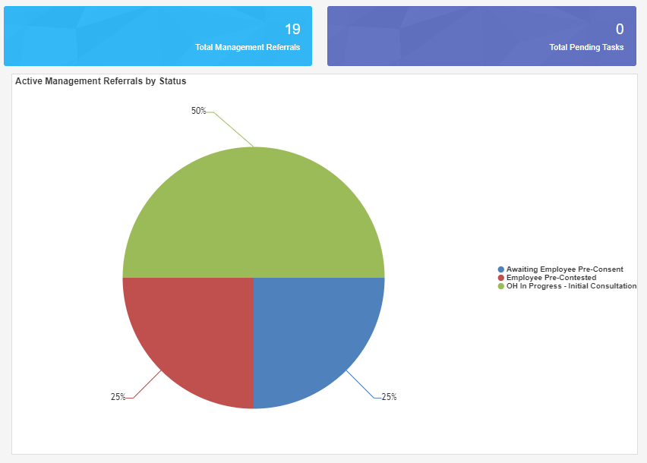

The right-hand side of the screen will show recent management Referrals. Select the Referrals from here or select the ‘Total Management Referrals’ blue panel at the top of the screen to show all of your referrals.
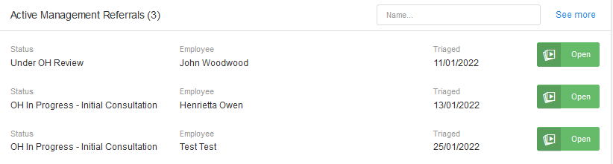

Creating a Referral
From the Referrals Menu on the left-hand side select ‘Management Referral’

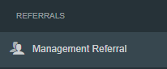

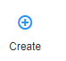
Select ‘Create’ from the top right-hand side.

Complete all of the ‘Referral Details’

The first section will ask about the referrer. Please note the information will be automatically filled out with the login being used.
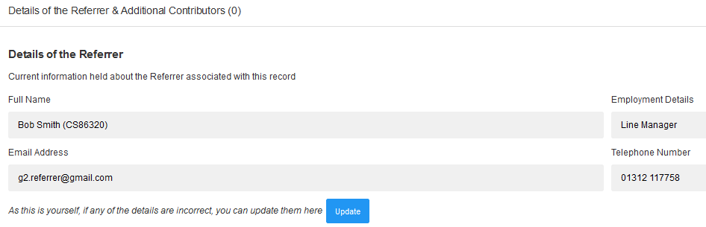
Mandatory questions are signified with a red Asterix *

Additional Contributors can be added if needed, they will need be able to see the final OH advice.
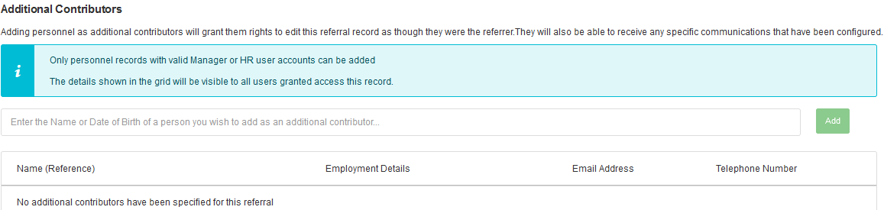

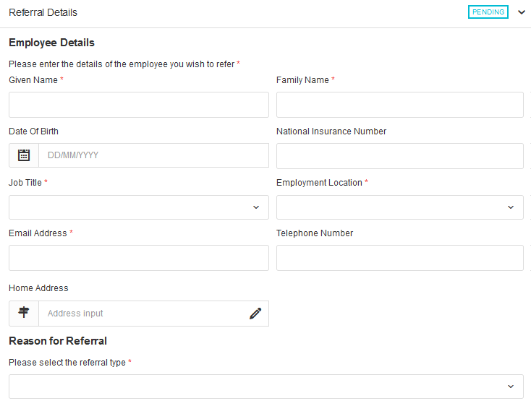
Next, the employee’s details need to be added to the referral, along with the reason for referral.

Scroll down and complete all sections relevant to the referral, working environment, absence details and Job Role Specifications.
Finally complete the ‘Advice required from Occupational Health’, attach any required documents and complete the declaration.
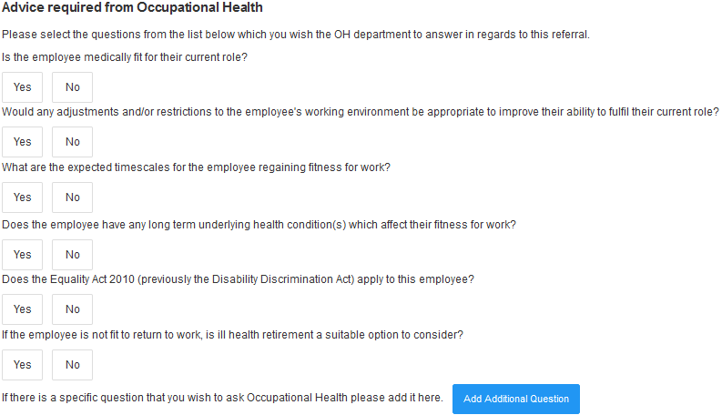
The user does not have to select all the questions but just select yes to those which require an answer to.
Additional questions can also be submitted using the ‘Add Additional Questions’ button.

The Manager must confirm if they have or don’t have the employee consent
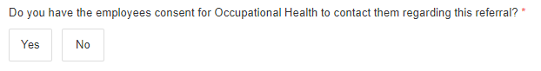

Once all sections are complete select ‘Submit to OH’ from the top right.
Note – the referral can be saved at any point using the save icon here.

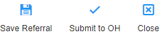

Confirm submission of the Referral by selecting ‘OK’
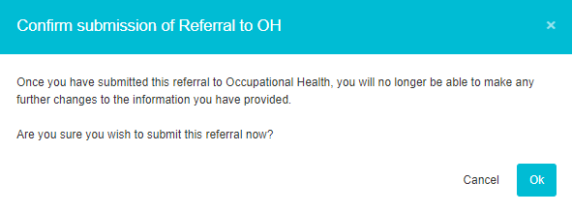

Confirmation that the Management referral has saved will display.
The confirmation will also detail any automated communications that have been sent.
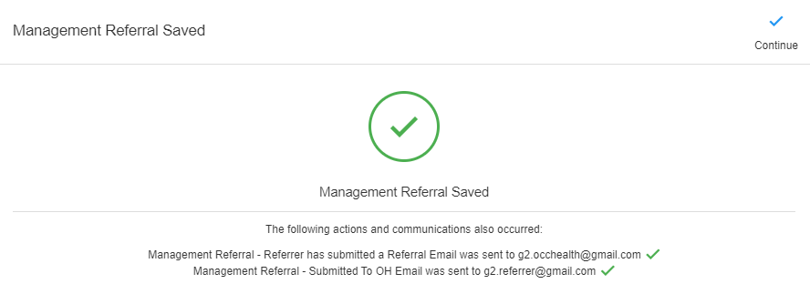

Select ‘Continue’

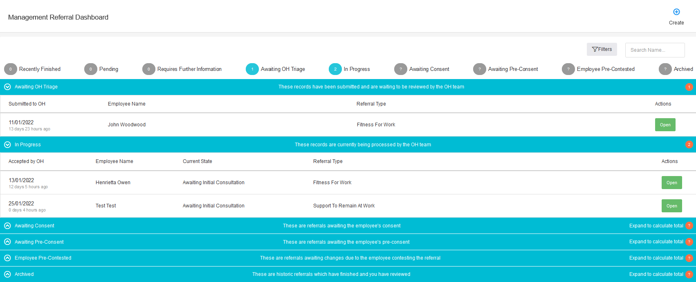
The Management Referral Dashboard will display

The submitted Referral will now display under ‘Awaiting OH Triage’.
The progress of the submission can be monitored using the blue bars
Management Referrals can be deleted after submission. However, they cannot be deleted once OH triage the submission.

Consent

Pre-Consent (Not Applicable for referrals to APOHS)
Pre-consent is a feature that can be turned on or off in the G2 system. If Pre-consent is turned on when the Referrer has completed the referral, an email will be sent to the employee asking for their consent.
Its only when the employee gives their consent will the referral arrive with the OH department.
Pre-Consent can only be turned on or off by a Administrator

Once turned on by the Administrator, when a Manager completes the Referral form they will no longer see an option to send to OH.

Instead, the option will be to ‘Submit & Request Consent’
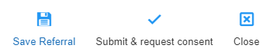

A notification will show an email has been sent to employer to gain consent
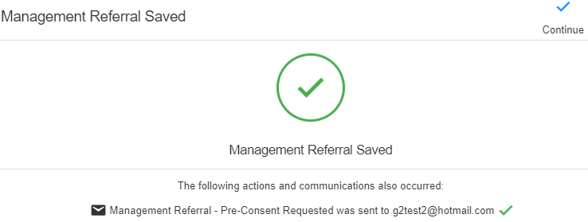

In the Management Referral Dashboard, the referral will now be marked as “Awaiting Pre-Consent”
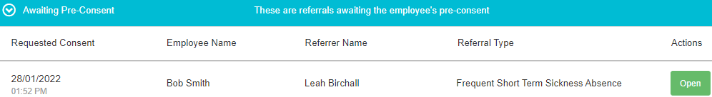

The Employee will now receive an email asking for their consent

Status Updates as OH Progress the Referral
As the referral is progressed by the OH Team the status of the referral will update. You will not be able to see any clinical information, but you will be able to see a timeline of events.
Select either of the ‘Management Referrals’ options from the homepage
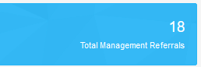


The Management Referral Dashboard will display.

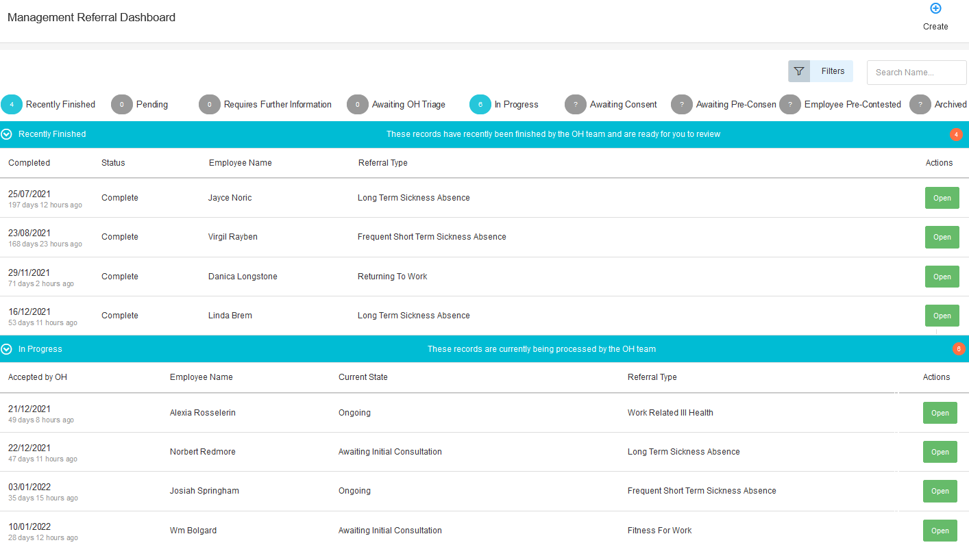

You can see the status of any referral in the corresponding section
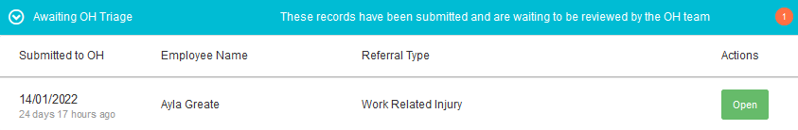

Or use the filters to narrow down the number of referrals you have submitted reason or type


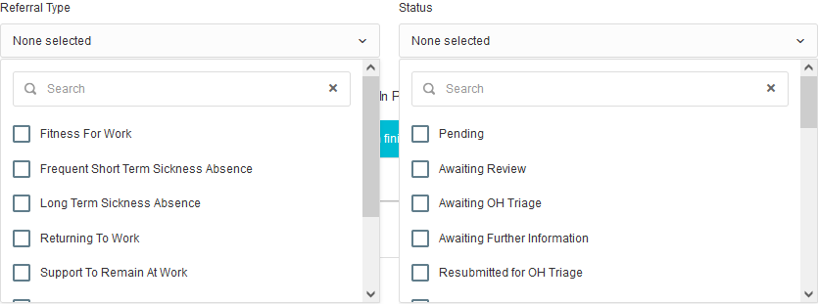

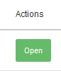
To review more details, select to ‘OPEN’ a refer

The status will display at the top of the page
You can review the details originally submitted on the left of the page.
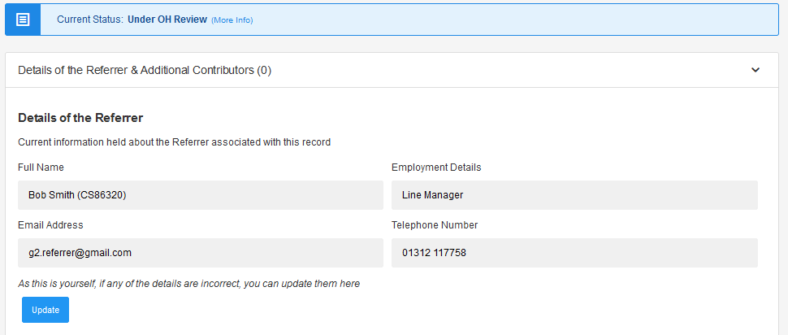

A timeline of events will show down the right-hand side of the page. This will update LIVE as appointments are added and completed.
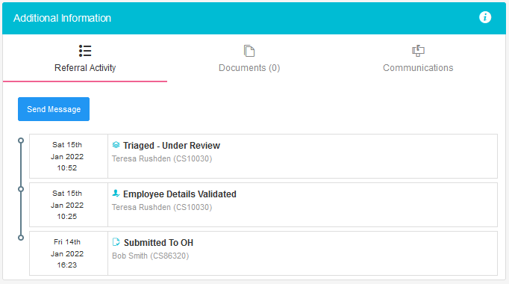

Receiving A Response from the OH Team
Whenever a consultation is completed, and a corresponding update is completed to be shared with you as the referrer, this will be done via the application.
Please Note - This is pending Employee Consent being provided to share the report.
When a response/report is ready you will be notified by email. This will confirm the name of the employee and that a report is ready. No further information will be shared.

The referral may appear in the ‘Recent Referrals’ on the home page
If not select ‘Management Referrals

From the Dashboard select to ‘Open’ the corresponding referral. This should be under ‘Recently Completed’

The timeline will show the referral is completed.
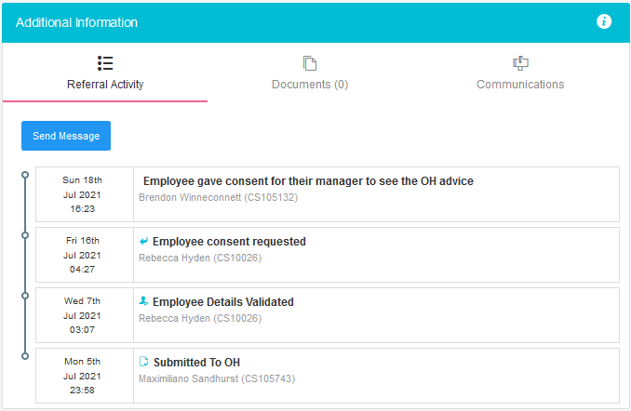
The main body of the page will display the original referral AND an OH advice section.
This is the feedback from the OH Team to you as the manager or referrer.

The OH Team will have answered the questions you requested, provided any further relevant information.

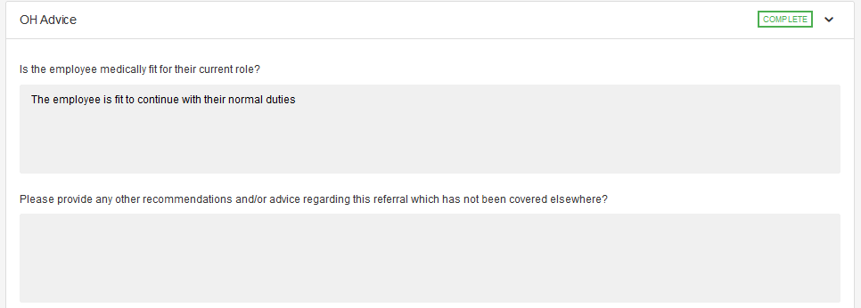

And detailed any adjustments required
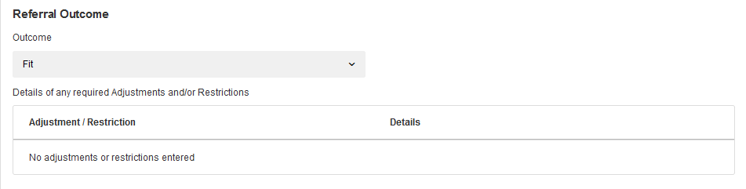

Interim Updates
If the referral is still ongoing, but the OH Team wish to provide an interim update the same process as above will apply.
An email will be received confirming a response has been provided.
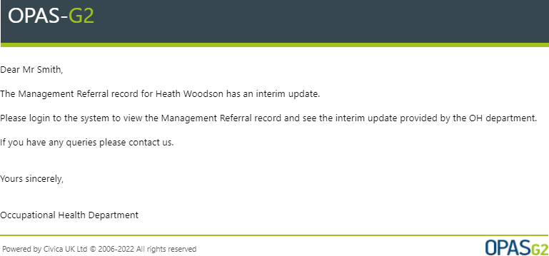

Log in and open the record as details above, under the ‘In Progress’ section of the Management Referral Dashboard
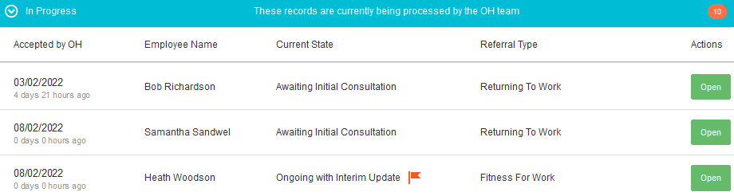
The Interim Updates will have the current state of ‘Ongoing with Interim Update’ and will have a
Click ‘Open’

This provides the same information as the OH Advice detailed above but is an Interim report. The Referral is ongoing and the OH Team may yet have further consultations or actions with the employee

Document Control
Document Control:
Version: | Author: | Date: | Comments: | Status:
1.0 | Jonathan Sidaway | 14/01/2022

Copyright Notice:
The content of this document is protected by copyright © Civica UK Limited 2023. All rights reserved. You may not copy or replicate including extracts of it without Civica’s written consent. You must not sell, share, copy or republish this document.
Copying of this document in any form is prohibited.
If you want further copies of this document, please make a request to the author shown on the front page.

