
OPAS G2
Pre-Placements
January 2022
Contents
Introduction 3
Using the G2 System 4
HR Dashboard 5
Pre-Placment Dashboard 6
Creating a new Pre-Placement 7
Applicant Questionnaire Completion 10
OH Triage 14
Discharge 18
Further Review Required 19
Complete Outcome 20
Arrange Consultation 23
Initial Consultation 25
Completing the Pre-Placement 27
Sending Notification to HR 29
Document Control 30
Copyright Notice: 30

Introduction
This guide is to details how a user of the OPAS G2 uses Pre-Placements in G2.
The guide will explain the following information:
- Using the G2 System
- Pre-Placement Dashboard
- Creating a new Pre-Placements
- Applicant Questionnaire completion

Using the G2 System

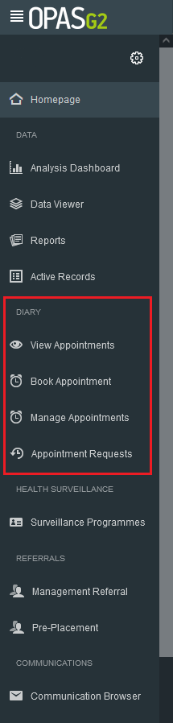
Use the Menu on the left-hand side as the main navigation through the system.

This user guide focuses on Pre-Placements.

HR Dashboard
Log in as HR

The HR dashboard will display
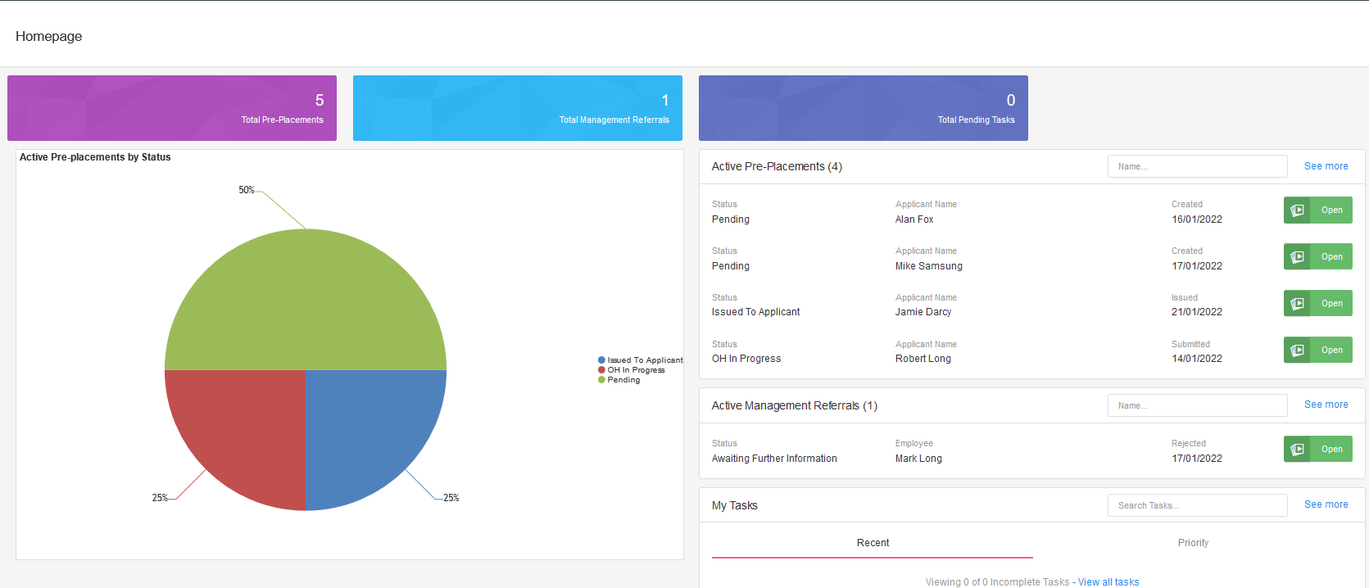
To Resume/review any ongoing cases select ‘open’ from the active pre-placements list.

Please Note – Depending on the given permissions, a HR licence can either see the Pre-Placements raised by the user or all pre-plaements raised in the organisation.

Please Note – to expand the active pre-placements selection select ‘see more’

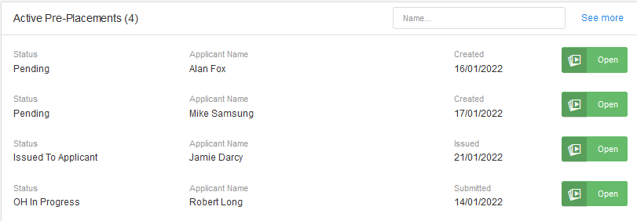

Pre-Placment Dashboard
To view the Pre-Placement dashboard
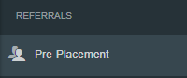
Select ‘Pre-Placement’ from the left hand Referrals menu.

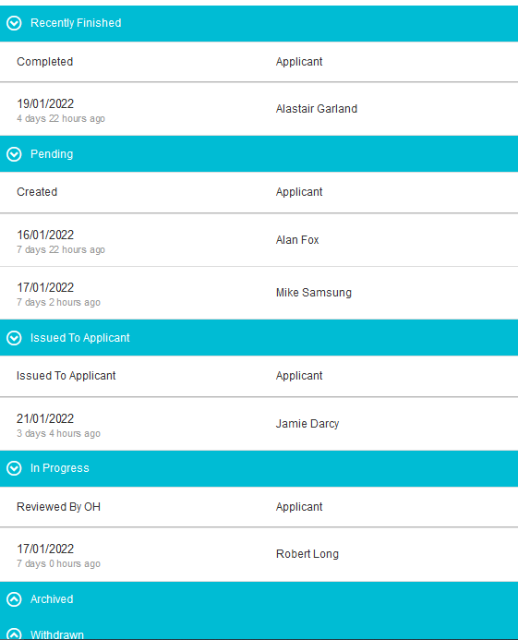

All recently finished, Pending, issued to applicant, in progress, archived and withdrawn are listed here.

Its also here you can create a new Pre-placement.

Creating a new Pre-Placement

Select ‘Pre-Placement’ from the left hand Referrals menu.

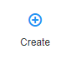

Select ‘Create’ from the top right of the screen

A new started Health Questionnaire will open
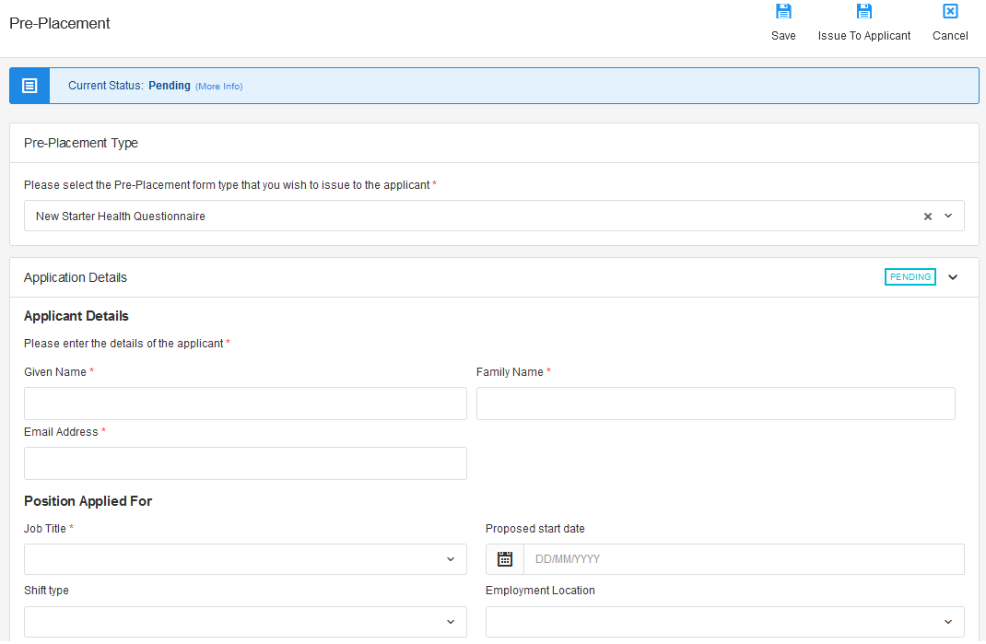

Complete all applicant and position applied for details.

Complete all questions regarding ‘Job Risks & Tasks’.
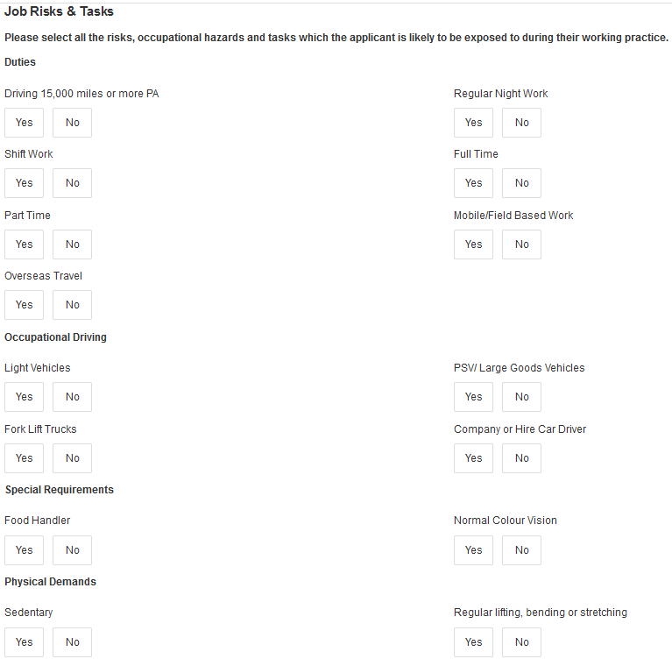
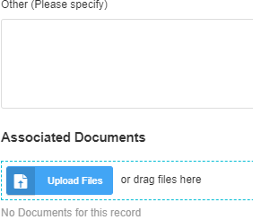

Specify any other relevant infomration and attach any required documents.

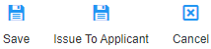
Once completed select ‘Issue to applicant’ from the top right.

Confirm that the pre-placement is ready to be issued to the applicant.

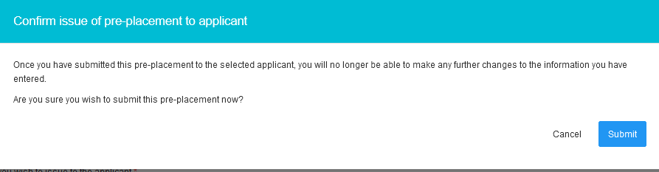
Select ‘Submit’

Confirmation of saving the pre-placement along with notification that any relevant emails have been sent will display.

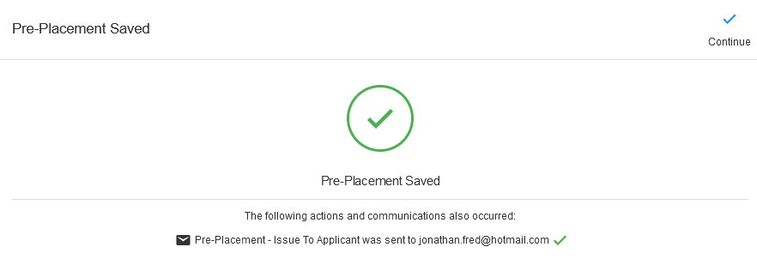
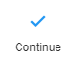
Select ‘Continue’

The Pre-Placement Dashboard will display.
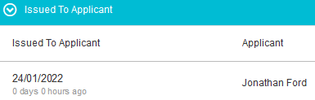

The Questionnaire that has been sent to the applciant will display under ‘Issued to Applicant’

Applicant Questionnaire Completion

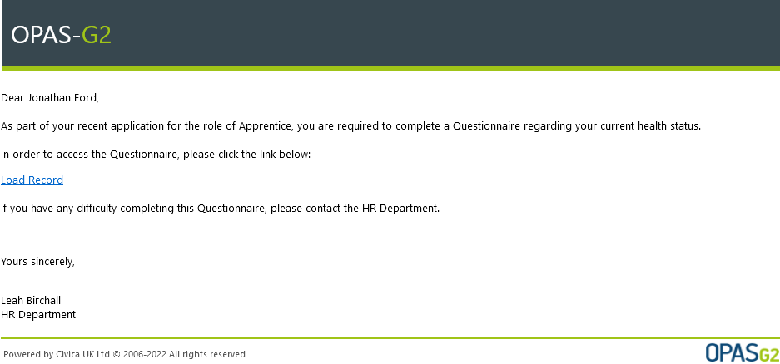
The applicant will receive a prompt email

Select ‘Load Record’

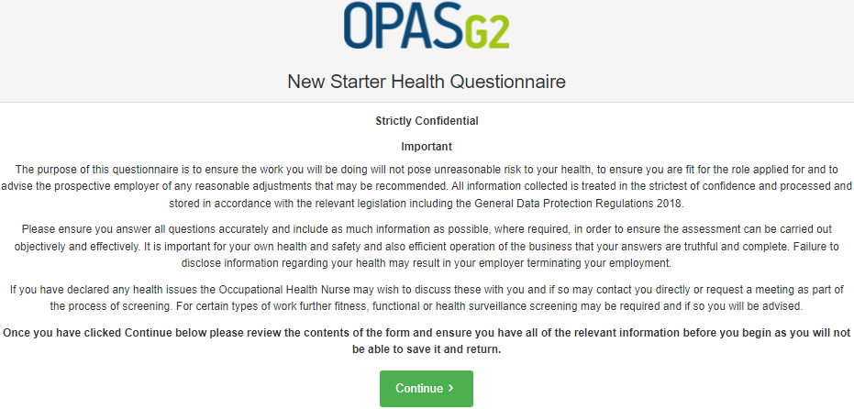
The data protections an handlingmessage will display

Select ‘Continue’

Please Note – If the applicant moves away from the questionnaire before submission, they will loose their entered data.
The questionnaire will display for completion.

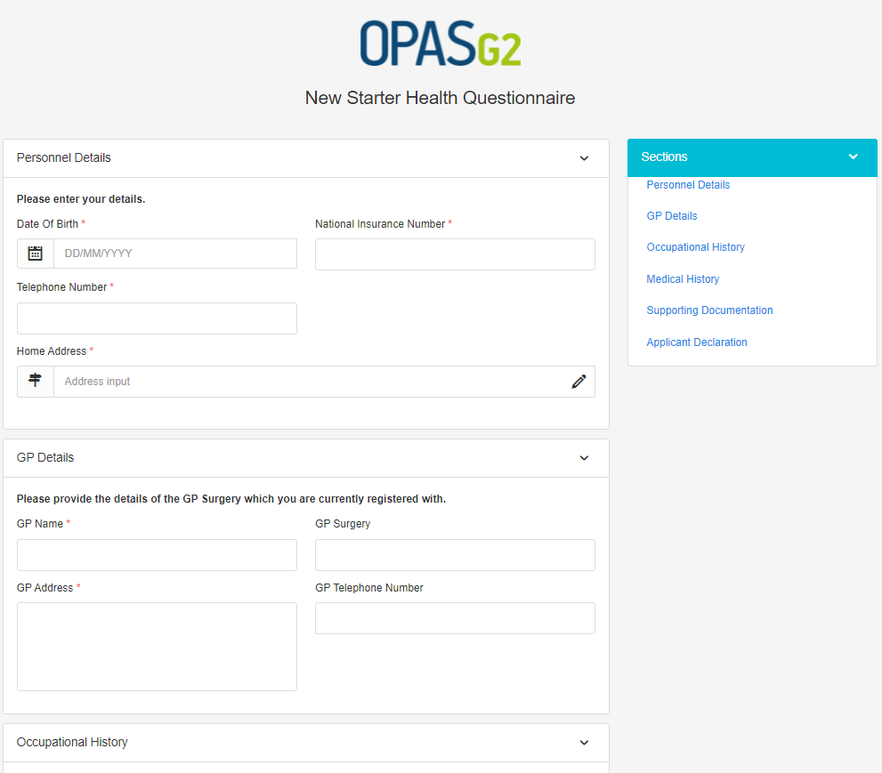

At the end of the questionnaire the applicant will be asked to complete the Declaration prior to submitting the form.

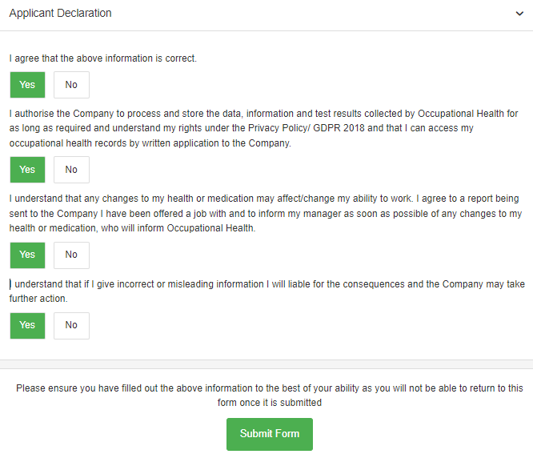

Once completed, select ‘Submit Form’

On submitting if any manydatory fields are not completed these will be highlighted.
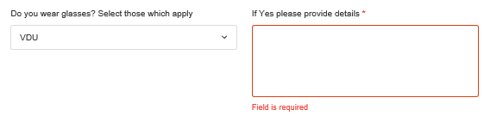

Complete the missing fields and submit the form.
The screen will prompt the form is being submitted.
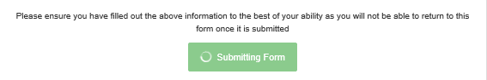

Confirmation of the completion will display.

The questionnarie has now been submitted back to OH for processing.



The applicant wil receive an email to confirm the questionnarie has been submitted.
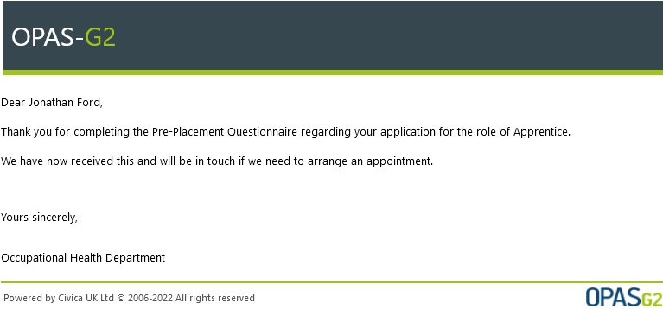

Document Control
Document Control:
Version: | Author: | Date: | Comments: | Status:
1.0 | Jonathan Sidaway | 14/01/2022

Copyright Notice:
The content of this document is protected by copyright © Civica UK Limited. All rights reserved. You may not copy or replicate including extracts of it without Civica’s written consent. You must not sell, share, copy or republish this document.
Copying of this document in any form is prohibited.
If you want further copies of this document, please make a request to the author shown on the front page.

